Team 1 Open Source Air Quality Monitoring

Week 12: March 20th 2022 - March 27th 2022

Sponsor: Dr. [David Burnett](mailto:dburnett@pdx.edu)

Advisor: Dr. John Acken

Team Members: [Adam Dezay](mailto:adezay@pdx.edu), [Manuel Garcia](mailto:manga2@pdx.edu), [Brandon Hippe](mailto:bhippe@pdx.edu), Mercedes Newton

**Team Review:**

* All team members are connecting to and coding in Energia.
* Team members are each working on specified sensor/component tasks.
* Enhanced gantt chart as shown in figures 1 and 2.
* Moved team meetings to better accommodate schedules.
  + New times, effective immediately are Monday @ 4:30pm, Tuesday @ 7:30pm, Thursday @ 7:30pm .
* Team changed meeting time with Dr. Acken for the upcoming term.
  + Starting April 6 we will be conducting Thursday 3pm advisor meetings.
  + Affective April 3rd Monday @ 7pm, Thursday @ 3 and Friday at 7pm
* Team intends to finish individuals codes and begin code meshing this week

**Individual Review**

Adam Dezay:

Worked with Brandon on getting I2C with energia working. Yet to have full success connecting with our hardware, however prospects look positive on making progress this upcoming week.

Manuel Garcia:

Did not have a chance to do a ton of work on the project this week preparing for finals. Plans in place to dedicate time to the project before the next report.

Brandon Hippe:

Shifted to working on making libraries for CO2 and PM2.5 sensors due to traveling for break. Finished coding them, but don’t have hardware to test with. Code is uploaded to github.

Mercedes Newton:

PM2.5 sensor updates - No updates, planning on finishing up sensor code and connection this week.

**Gantt Chart and Timeline Updates:**

Below is both the general timeline of the project as a whole as well as a breakdown of the specific tasks that are left moving forward. Gantt charts in figures 1 and 2 as well as table 1 are representative of the timeline for this term only. Figure 3 represents an outline of the schedule for spring term. Our team has factored in additional time for potential delays, however the current dates are subject to change. We intend to have our 3 modes built by the end of may, as displayed in our figure 3 gantt chart.

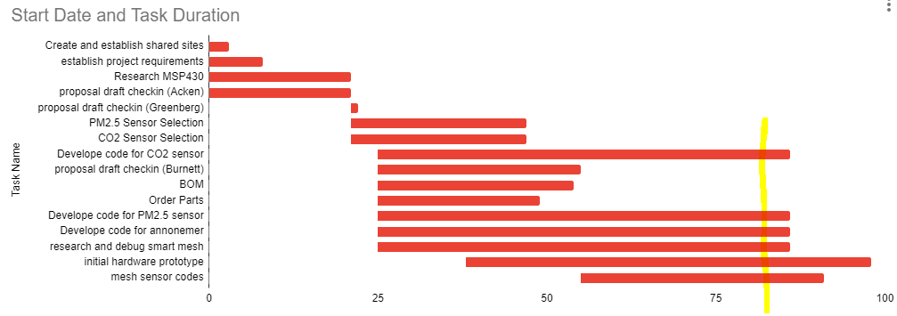

Figure One: Gantt chart with updated deadlines, highlighted line signifies today’s date, monday 3/27/23

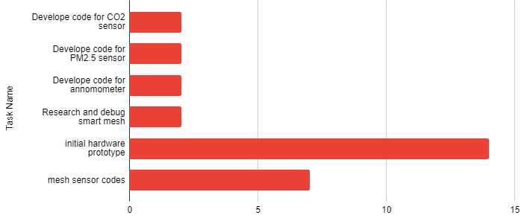

Figure Two: Pending tasks with updated finishing dates in relation to current date 3/27/2023

| Task Name | Expected Completion Date |
| --- | --- |
| Develop code for CO2 sensor | 3/29/23 |
| Develop code for PM2.5 sensor | 3/29/23 |
| Develop code for anemometer | 3/29/23 |
| Research and debug smart mesh | 3/29/23 |
| initial hardware prototype | 4/10/23 |
| mesh sensor codes | 4/3/23 |

Table 1: current tasks with updated expected completion dates

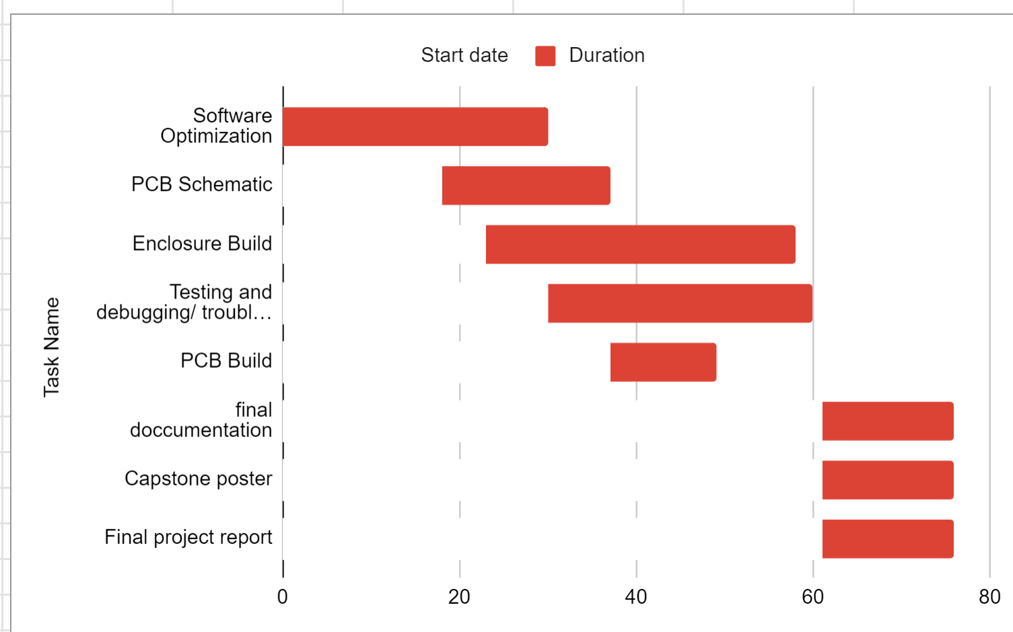

Figure three: Gantt chart for Spring term starting April 1st 2023

| Task Name | Start date | End date |
| --- | --- | --- |
| Software Optimization | 4/1/2023 | 5/1/2023 |
| PCB Schematic | 4/19/2023 | 5/8/2023 |
| Enclosure Build | 4/24/2023 | 5/29/2023 |
| Testing and debugging/ troubleshooting code | 5/1/2023 | 5/31/2023 |
| PCB Build | 5/8/2023 | 5/20/2023 |
| final documentation | 6/1/2023 | 6/16/2023 |
| Capstone poster | 6/1/2023 | 6/16/2023 |
| Final project report | 6/1/2023 | 6/16/2023 |

Table two: Tasks for spring term with expected completion dates *completion dates subject to change*